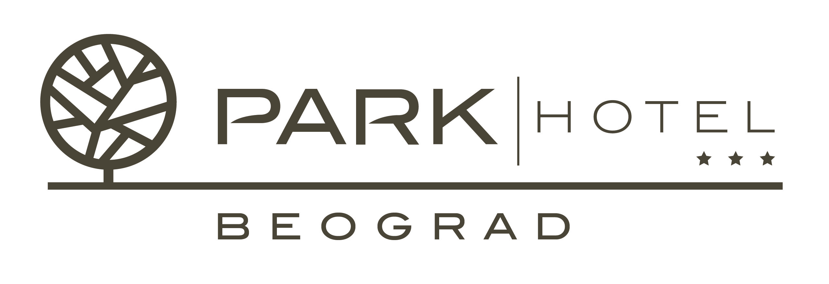

HOTEL RESERVATION FORM

Hotel Park Beograd welcomes the guests of
9th INTERNATIONAL CONFERENCE ON THE OCCURRENCE, PROPERTIES AND UTILIZATION OF NATURAL ZEOLITES – ZEOLITE 2014
We are pleased to advise the special rates and conditions available for this event:
(please check appropriate box)

Single room at special rate of 50 € daily per room
Double room at special rate of 70 € daily per room

All the above mentioned rates are INCLUSIVE of full buffet breakfast in our Continental restaurant, VAT, complimentary internet access and use of Hotel’s recreation and sports facilities.
City tax is not included and is approximately. 1.3 € per person daily.

GUEST INFORMATION:
Family name:
First name:
e-mail:
Contact phone number:
Date of arrival: | Date of departure:

PAYMENT INFORMATION:
BY CREDIT CARD: | Visa | Master | Diners |  | American Express
Card Holder name:
Card Number: |  |  |  | Exp. Date:
Cancellation Policy: If you wish to cancel, please do so at least 72 hours prior to arrival. For all cancellations or no shows after this period, one night charge will be charged to your credit card.

PLEASE COMPLETE THIS FORM AND SEND TO HOTEL PARK BEOGRAD VIA FAX OR E-MAIL BY APRIL 1st, 2014.

